
Scientific Investigations

The Goal of Science
All scientific inquiry (physics, chemistry, biology, psychology, geology, and so on) is typified by the use of the scientific method. Scientific predictions must:
- Be based on empirical evidence.
- Make testable, useful predictions.
- Be falsifiable (but hopefully not false).
True or false: if an experiment supports a hypothesis, then the hypothesis must be true.
Which of the following are testable and falsifiable? For each testable statement, suggest a test that could disprove it or support it.
- The moon is made of cheese.
- The best colour is cheese.
- Humans will die without access to cheese.
- The ancient Egyptian chancellor Imhotep worshipped the god of cheese.
- Gravity follows an inverse square law.
- Atoms are the smallest units of matter.

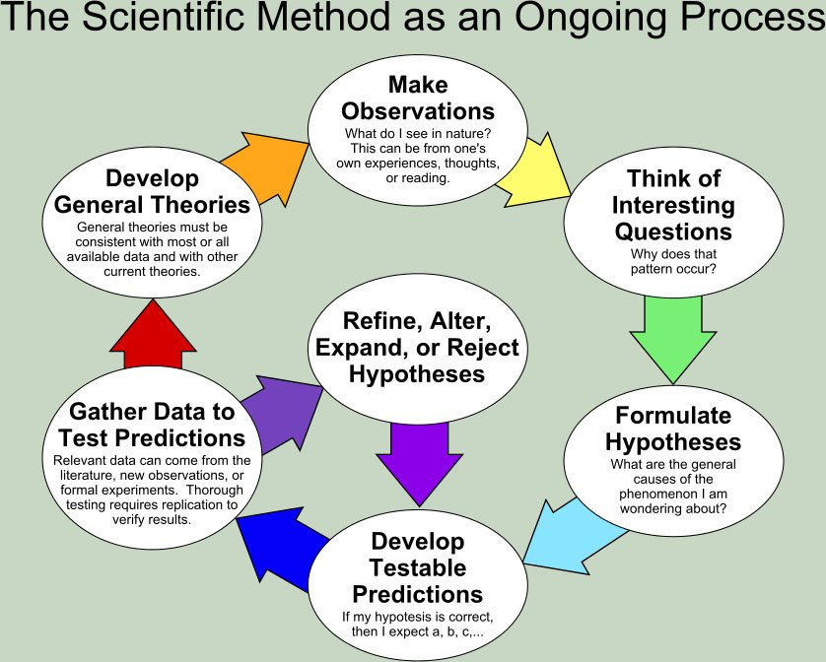
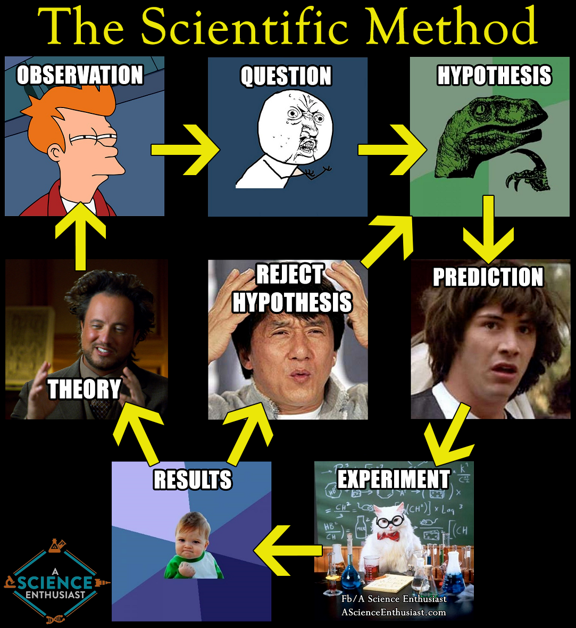

Make Observations and Think of Interesting Questions
- If I drop a metal rod through a metal tube and I choose the right metal, it slows down!
- What happens if I drop a cheeseburger in acid? (https://www.youtube.com/watch?v=NddZ5ftQb0Q)
- What is formed if we smash protons together at high speed? (https://www.youtube.com/watch?v=ZcB6FfAxKlY)
- If I mate together a zebra and a horse, will the resulting offspring be viable? (google Zebroid)
- What salt will be formed when I mix vinegar and bleach? Will everything react?

Formulate Hypotheses
- Ethanoic acid is CH₃CHOOH; when I mix it with NaOH, I predict that some CH₃CHOONa (sodium ethanoate) salt will be formed but the reaction will not go to completion because ethanoic acid is weak.

Develop Testable Predictions
- The pH of the solution will start off at around 2-3, and as I add NaOH the pH will slowly move towards 7. If I keep adding NaOH, the pH will eventually become 13-14.

- The product formed will be a white salt, soluble in water, with a high mp/bp, mass of approx 82 grams per mol, etc.

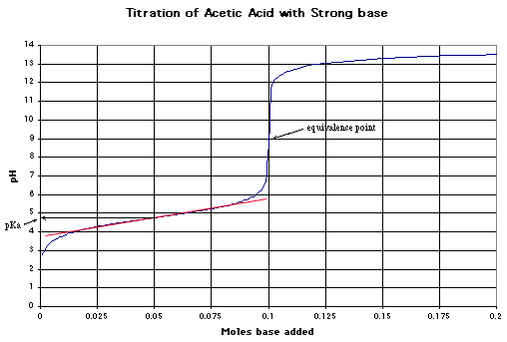
Gather Data

- After doing titration, found above titration curve.
- Mass spectroscopy of product shows acetate ions.
- Flame test of product for Na: orange flame, so yes.
- The more data we gather, the more accurate and precise our conclusion.
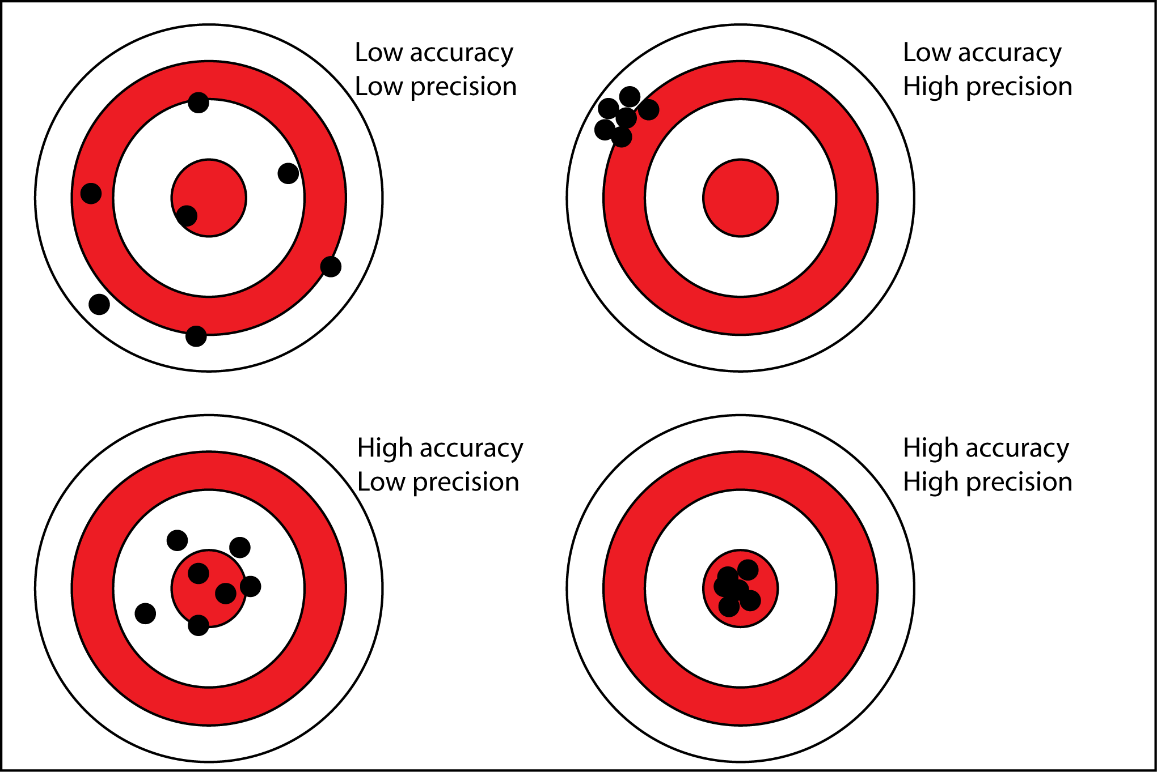

Develop General Theory
- Why does what happens happen?
- General theory: ions break up in solution and swap. NaOH is a proton acceptor so steals the H from the hydroxyl group on the acetic acid and donates the Na to the acetate ion.
- How can we test this more? HCl should form NaCl with NaOH, NH₃ should form NH₄Cl with HCl, etc.

Empirical evidence is evidence based on, concerned with, or verifiable by observation or experience rather than theory or pure logic.
A hypothesis is falsifiable if it is possible to conceive of an observation or an argument which could prove it wrong.

